# Week 12 Case study

This is our last case study for the semester!

In this weeks case study we will look further at understanding the standards and guidelines for small ruminants, nutrition and describing some of the outputs from the system.

## Exercise 1: Small Ruminant Nutrition

In extensive production systems it is not uncommon to need to feed some form of supplementary feed throughout the year. This may require moving stock into a containment zone or may involve feeding stock in larger paddocks. A containment zone will be used where stock are moving onto a full ration (100% of their requirements) as opposed to where they are getting extra rations to increase energy/protein in their rations, this is often earlier in the season when there is adequate quantity of pasture but lacking quality eg. may occur in January and then sheep moved to containment by March in a south-east Australian farming system.

A key part of deciding on a ration is finding the lowest costs feed that is adequate quality to meet the animals needs. This is generally based on assessing the energy in feed (using a feed test) and then calculating a cost per MJ. The feed type used however MUST be adequate quality to meet the animals needs when eating an acceptable volume eg. a feed with 45% digestibility is never going to be adequate for sheep to gain weight (or retain weight).

Please review Chapter 3 of <https://www.feedinglivestock.vic.gov.au/wp-content/uploads/2019/03/Sheep-drought-feeding-guide.pdf> (particularly page 37).

What is the cheapest feed to provide to sheep this week if we needed to feed fodder to sheep? We can use the dairy Australia site to find current pricing.

<https://www.dairyaustralia.com.au/industry-statistics/industry-reports/grain-report>

<https://www.dairyaustralia.com.au/industry-statistics/industry-reports/hay-report>

What might be other challenges for feeding some kinds of supplementary feeds?

You can check your answers using this handy calculator with respect to converting to price per MJ (but work it out yourself first to ensure you know how to do it).

<https://www.agric.wa.gov.au/feeding-nutrition/feed-cost-calculator>

## Exercise 2: Implications of standards and guidelines

In the following examples list where the enterprise is not following standard and guidelines for sheep.

**Stud sheep example.**

A stud British Breed Sheep Producer lambs their ewes in May. Each day they go around the ewes to tag lambs to their dams so they can identify the dam and sire (they have records for which sire was in the same paddock as the dam). Each lamb is tagged, weighed and has their tail docked on the day of birth so they are identified permanently at that point. Tail docking is done as they lambs are already restrained so it means the job can be done quickly and easily. This process is done in the morning so any disturbance is not impacted in the evening when a lamb being away from its dam is more likely to result in a bad predation outcome overnight as this is the worst time for fox kills.

Lambs stay on their dams until they are at least 10 weeks of age and up to 17 weeks of age on the farm as these short wool British breeds are relatively high milk producers. One month before weaning they receive their first vaccination and at weaning they receive their second vaccination and a weaning drench. When the average lamb is aged 6 months they are all weighed, muscle and fat scanned. All data (birth weight, weaning weight, post weaning weight, muscle score and fat score) are then sent to SGA for analysis. Once ASBVs are then available for the ewes and rams they are assessed on phenotype and genotype, including genomics for a limited number of stock that are considered the highest quality. Rams that are not going to be sold to either stud or commercial clients are then castrated using scalpel and emasculators. Cull ewes and wethers are then sold at the soonest sales as the lambs are already a heavy weight. A picture of a typical ram is below:

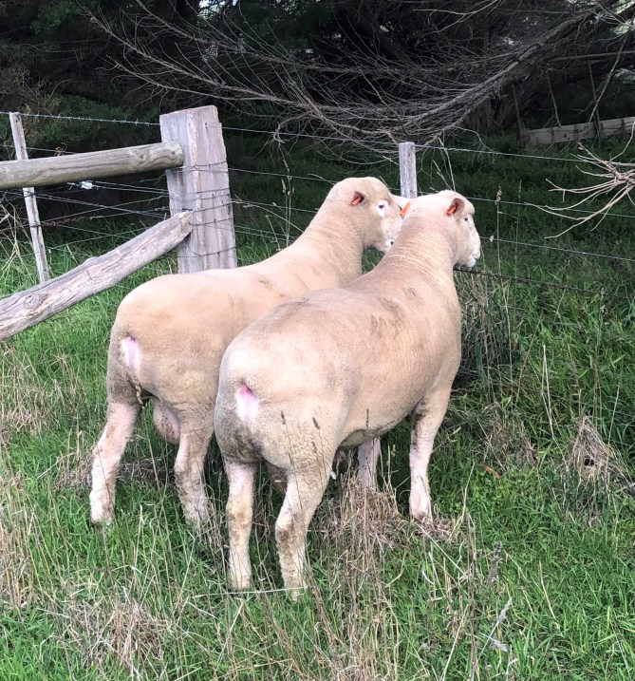

The ram lambs are treated twice with 6 in 1 vaccine, 4 mL dose each time. At weaning they are treated with 4 mL Qdrench orally.

## Exercise 3: Outputs

A: A farm wishes to target the heavy North American lamb market with carcass weight of 26-30 kg and fat score of 3-4. Describe the enterprise needed to achieve this.

List the breeds, likely zone within Australian agriculture and age of lamb at sale time. What are the other likely outputs from the enterprise and relative contribution to total income? What are the animal health products that this lamb is likely to receive in its lifespan?

B: A fine/medium Merino enterprise mates cull Merino ewes to a White Suffolk ram. What market are these lambs most likely destined for?